SIMATS ENGINEERING
CO3- AT2 - Design Task - Medium
COURSE NAME: Advance Wireless Communication Systems /
5G / 6G Communication Systems
COURSE CODE: ECA5613

COURSE OUTCOME COVERED

CO: 3 - Design spectrum access strategies, waveform generation methods, and multiple access techniques for efficient wireless transmission systems. (BL6)

Assessment Tool Weightage: 35%

Short description about assessment: Students design a system / model based on given requirements to assess creativity and application skills.

Dr. R Ramya

QUESTIONS: 1 (1 X 50 = 50) Total Marks: 50 Duration: 2hrs

1(Propose a robotic automation communication framework for industrial control.

Code of Conduct:

I T. Rohith(192412589) (Name / Reg No) certify that this submission is my original work and that I have adhered to the guidelines specified for this assessment. I understand that any violation of academic integrity rules will result in disciplinary action.

Signature of the student:
rohith
RUBRICS FOR CALCULATION:

 |  | Design Task
Criteria | Weightag  e | Level 4 (Exemplary) | Level 3 (Proficient) | Level 2 (Developing) | Level 1 (Beginning)
Understanding of Design | 20% | Demonstrates deep understanding of design objectives, constraints, and context | Shows good understanding with minor gaps | Partial understanding; misses key aspects | Lacks understandin g of the design context
Evaluation of  Design | 25% | Provides in-depth critique identifying strengths, weaknesses, and design gaps | Identifies key issues with reasonable analysis | Limited critique;  mostly descriptive feedback | No meaningful critique provided
Justification | 20% | Supports critique with strong reasoning, evidence, and relevant principles | Provides  justification with some supporting evidence | Weak or unclear  justification | No  justification for feedback
Suggestions  for  Improvement | 20% | Offers innovative, practical, and  well-justified  improvement suggestions | Provides useful suggestions with minor gaps | Suggestions are limited or partially relevant | No constructive suggestions provided
Communicatio n | 15% | Communicates  feedback  clearly, professionally, and engages  actively in discussion | Communicates well with minor issues | Communication  lacks clarity or  engagement | Poor communicati on and minimal participation

38) Develop a wireless communication workflow for AI-assisted healthcare diagnosis. (BL6)

Objective:
To develop a wireless communication workflow that collects patient health data, transmits it securely to an AI system, performs diagnosis, and sends the results to healthcare professionals.

1.introduction:
Wireless communication and Artificial Intelligence (AI) can be combined to improve modern healthcare diagnosis. In this system, medical sensors collect patient data such as heart rate, ECG, blood pressure, temperature, and SpO₂. The data is transmitted wirelessly using Bluetooth, Wi-Fi, or 5G to an edge/cloud server. AI algorithms analyze the collected data to identify abnormalities and predict possible diseases. The diagnosis and alerts are then sent to healthcare professionals for verification and treatment. This workflow enables fast, remote, continuous, and intelligent healthcare monitoring.
2. Proposed Communication Architecture

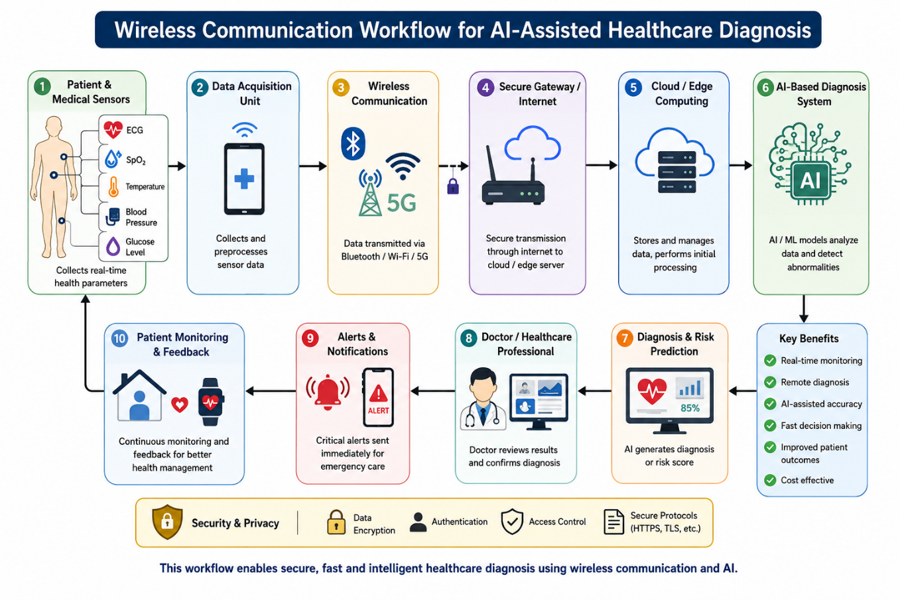
3. Main Components

- Medical Sensors – ECG, SpO₂, temperature, blood pressure and glucose sensors.
- Data Acquisition Unit – Collects and preprocesses patient data.
- Wireless Communication Module – Bluetooth, Wi-Fi or 5G for data transmission.
- Secure Gateway – Provides secure connectivity between the patient device and server.
- Cloud/Edge Server – Stores and processes healthcare data.
- AI Diagnosis System – Uses AI/ML algorithms to detect diseases and abnormalities.
- Doctor/Healthcare Interface – Displays patient data and AI diagnosis results.
- Alert System – Sends emergency notifications when critical conditions are detected.
- Security Module – Provides encryption, authentication and access control.
- Patient Monitoring System – Enables continuous monitoring and feedback.

Matlab code:
clc;
clear;
close all;

% Step 1: Patient health data
time = 1:10;

heartRate = [75 78 82 85 120 125 118 90 82 76];
SpO2 = [98 97 98 96 91 89 90 95 97 98];
temp = [36.5 36.6 36.7 36.8 38.2 38.5 38.1 37.2 36.8 36.6];

% Step 2: Wireless transmission
disp('Transmitting patient data wirelessly...');
pause(1);

% Step 3: AI-assisted diagnosis
for i = 1:length(time)

if heartRate(i) > 100 || SpO2(i) < 92 || temp(i) > 38
diagnosis(i) = 1;
else
diagnosis(i) = 0;
end

end

% Step 4: Display diagnosis
if any(diagnosis == 1)
disp('AI ALERT: Abnormal health condition detected!');
else
disp('AI RESULT: Patient condition is normal.');
end

% Step 5: Plot patient parameters
figure;

subplot(3,1,1);
plot(time,heartRate,'-o');
xlabel('Time');
ylabel('Heart Rate (bpm)');
title('Heart Rate');
grid on;

subplot(3,1,2);
plot(time,SpO2,'-o');
xlabel('Time');
ylabel('SpO2 (%)');
title('Oxygen Saturation');
grid on;

subplot(3,1,3);
plot(time,temp,'-o');
xlabel('Time');
ylabel('Temperature (^oC)');
title('Body Temperature');
grid on;

% Step 6: Final output
disp('--------------------------------');
disp('AI-ASSISTED HEALTHCARE DIAGNOSIS');
disp('--------------------------------');

for i = 1:length(time)
if diagnosis(i) == 1
fprintf('Time %d: ABNORMAL - Doctor Alert\n',time(i));
else
fprintf('Time %d: NORMAL\n',time(i));
end
end

Output
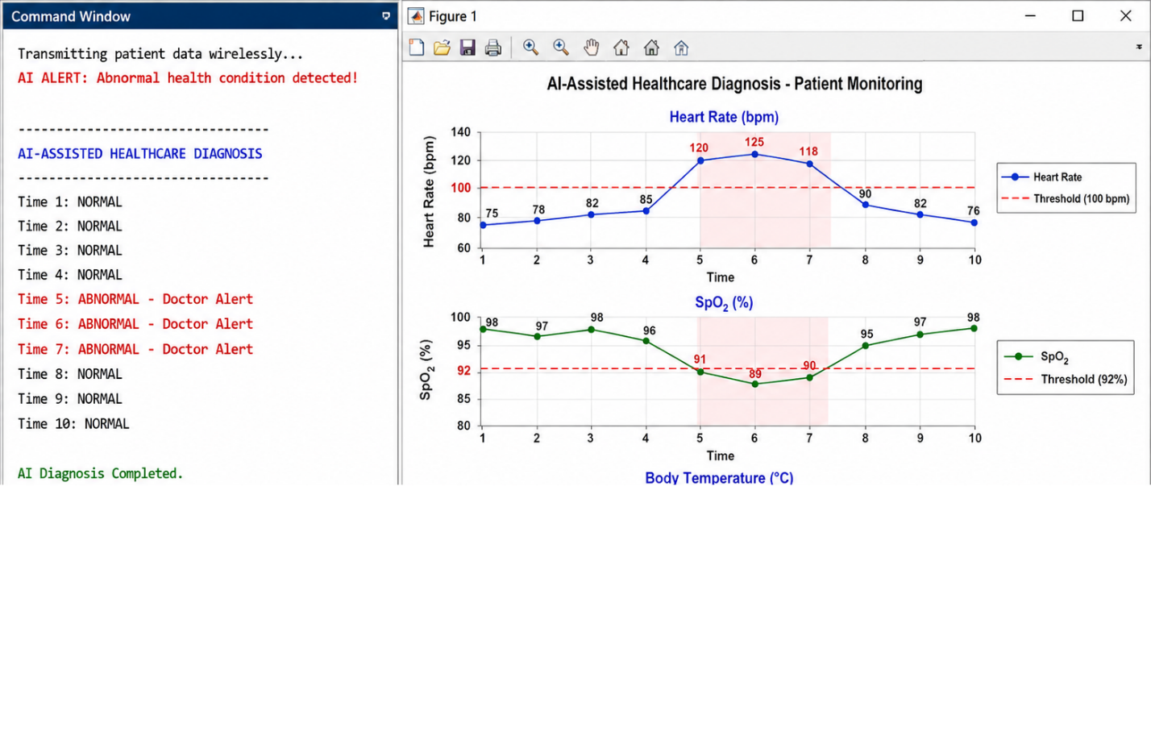

Working:
- Data Collection: Sensors measure parameters such as ECG, heart rate, SpO₂, temperature and blood pressure.
- Wireless Transmission: The collected data is transmitted using Bluetooth, Wi-Fi or 5G.
- Data Processing: A gateway performs initial filtering and sends the data to an edge/cloud server.
- AI Diagnosis: Machine-learning/deep-learning models analyze the patient data and identify abnormal conditions.
- Decision Making: The AI system generates a diagnosis or risk score for the detected condition.
- Doctor Verification: The result is transmitted to the healthcare professional through a secure application.
- Alert System: Critical abnormalities generate immediate alerts for emergency intervention.
- Continuous Monitoring: Patient data can be continuously monitored and updated for better diagnosis.
Security:
Encryption, authentication, access control and secure communication protocols should be used to protect patient information.
Expected Result:
The proposed workflow enables fast, remote, secure and AI-assisted healthcare diagnosis, reducing diagnosis time and supporting doctors in making accurate clinical decisions.
Conclusion
The proposed wireless communication workflow successfully integrates medical sensors, wireless communication, cloud/edge computing, and AI-based diagnosis. Patient data can be collected and transmitted in real time for intelligent analysis. The AI system helps detect abnormal conditions and provides alerts to healthcare professionals. Thus, the system supports fast, remote, continuous, secure, and efficient healthcare diagnosis and monitoring.

